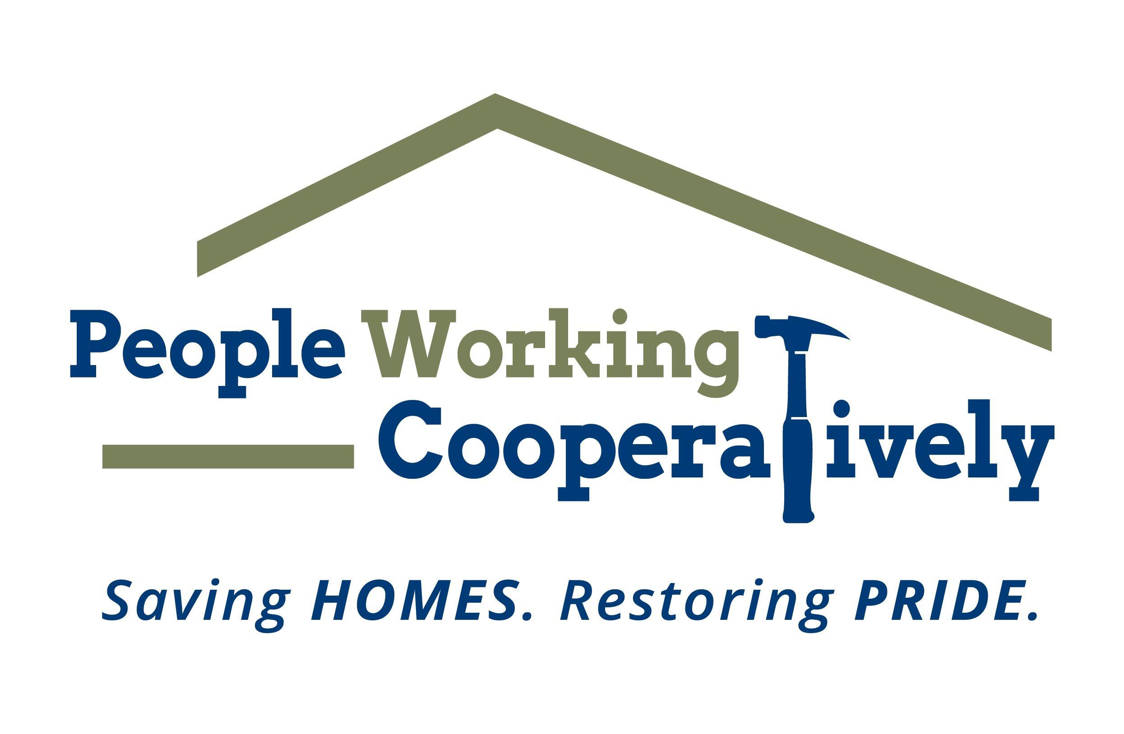
FOR IMMEDIATE RELEASE
Media Contact: Amber Potter, Scooter Media
513-236-8301 | amber@scootermediaco.com

Click here for photos.

People Working Cooperatively and Samuel Adams Cincinnati Taproom partner for the 2nd Annual “lager” than life competition
Registration is now open for local homebrewers to brew for a good cause and raise money for those in need

CINCINNATI (Feb. 21, 2023) –People Working Cooperatively (PWC) and the Samuel Adams Cincinnati Taproom are raising a glass to collaboration, homebrews and cornhole – all to support a great cause with the second annual Boards & Brews Homebrew Competition.

PWC’s Emerging Leaders Board and the Sam Adams Taproom are teaming up for the second year in a row to invite homebrewers of Greater Cincinnati to brew their best for a chance to have their beer made and released at the Taproom during the Boards & Brews cornhole tournament this summer. The deadline for teams to register is March 12.

“Last year’s Boards & Brews success paved the way for the event to return for a second year,” said PWC President Jock Pitts. “This collaboration between the Samuel Adams Cincinnati Taproom and PWC’s Emerging Leaders Board – a group of talented young professionals and emerging community leaders – is a great way to engage the community and raise awareness for the work PWC does in the region to provide critical home repair and mobility modification services to our neighbors in need.”

Registration is $150 per beer entry and includes a $50 stipend for brewing ingredients, as well as entry for up to five team members to the competition kickoff event on March 12 at the Taproom (1727 Logan St., Cincinnati). The kickoff event provides the opportunity for entrants to meet with Sam Adam’s Head Brewer Chris Siegman and tour the Taproom brewery facilities.

“Through this unique collaboration with PWC, we are able to support and applaud innovation in the brewing world while doing some good in the community,” said Keith Ely, Sam Adams Cincinnati Taproom General Manager. “We are excited to continue this partnership and look forward to another year of celebrating the region’s vibrant brewing culture providing meaningful support for those in the community that need it.”

Registration for the Boards & Brews Homebrew Competition is open through March 12 and can be completed online at http://www.pwchomerepairs.org/brew. Teams are allowed to submit more than one entry but must pay the registration fee for each entry. Cincinnati Malt Infusers certified judges will choose the winning homebrew, and that team will brew their recipe with Head Brewer Chris Siegman on-site at the Taproom for release at the Boards & Brews cornhole tournament to be held Aug. 6.

All proceeds from the Boards & Brews Homebrew Competition benefit the programs and mission of People Working Cooperatively. To learn more about People Working Cooperatively, or to find out who qualifies for services, visit pwchomerepairs.org or call (513) 351-7921.

# # #

About People Working Cooperatively
Incorporated in 1975, People Working Cooperatively (PWC) is a non-profit organization serving low-income, elderly, and disabled homeowners in 20 counties of southwest Ohio, Dayton, northern Kentucky and southeast Indiana. For 48 years, PWC has strengthened communities by providing professional, critical home repair, weatherization, and modification services to help residents stay safely in their homes. PWC’s staff of licensed, trained employees and dedicated corps of volunteers assist nearly 6,000 individuals in more than 3,500 homes each year. For more information, visit pwchomerepairs.org or call (513) 351-7921.

About The Samuel Adams Cincinnati Taproom
The Cincinnati Samuel Adams Taproom opened in November 2018 and is located near the historic Findlay Market and across the street from the Samuel Adams Brewery in Over-the-Rhine. It serves as a meeting place for beer drinkers, local Cincinnatians, and visitors alike where core, seasonal and even exclusive, experimental beers are available thanks to the proximity of the Brewery and the Taproom’s on-site research and development nano-brewery.

