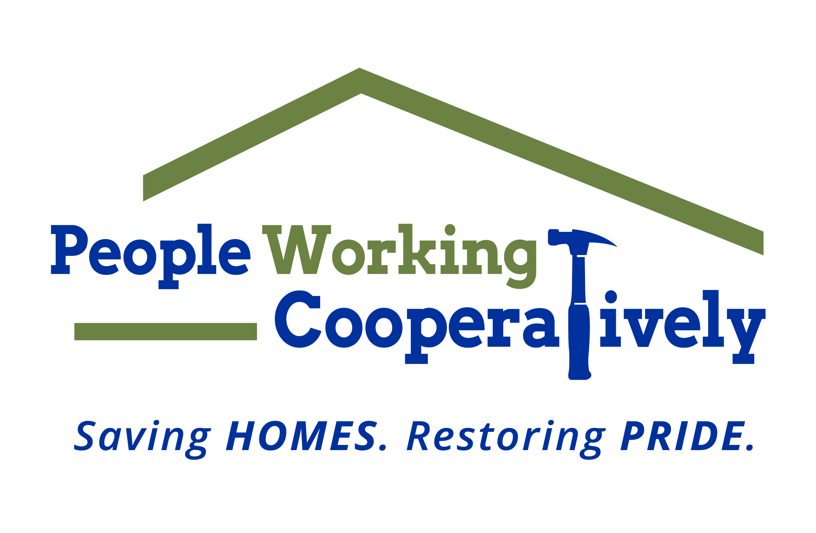
Media Contact: Jamie Glavic, Scooter Media
(859) 409-9943 | jamie@scootermediaco.com

FOR IMMEDIATE RELEASE

People Working Cooperatively Announces 45 Days of Service Anniversary Celebration
Safe, Socially Distant Community Volunteer Opportunities Oct. 1 - Nov. 14

Cincinnati, OH (September 9, 2020) – People Working Cooperatively (PWC) is seeking volunteers for its socially distant community volunteer initiative “45 Days of Service.” From October 1 to November 14, volunteers can give back and make a difference while helping the nonprofit celebrate its 45th anniversary of coming together to assist neighbors in need.

“The need for PWC’s volunteer services has continued throughout the pandemic, and it's now more important than ever to keep our clients safe and healthy in their own homes,” said Jock Pitts, President and CEO of People Working Cooperatively. “45 Days of Service is transforming our community volunteer efforts. Rather than having two large events, we're combining both into one volunteer initiative, following public health guidelines and providing safe, socially distant opportunities to give back. I can’t think of a better way to celebrate our anniversary with the community.”

Historically, PWC’s annual Prepare Affair and Repair Affair events have provided home repair and yard clean-up services performed by thousands of volunteers across the region over a period of two days. PWC has implemented the following guidelines for its 45 Days of Service:

- Volunteers will do outdoor work only, and will have no direct contact with PWC clients.
- Volunteer crew sizes are limited in order to maintain a safe distance when working. Larger groups will be asked to break into multiple teams.
- Volunteers will wear face coverings while on a job site.
- PWC will ensure there are mobile hand-washing stations and hand sanitizer at each job site in addition to any other PPE needs like gloves or safety glasses.
- Each crew leader will participate in a jobsite safety training to make sure every team has the tools they need to work safely while preventing the spread of COVID-19. This training will be offered virtually and in person.

“For our volunteers, these enhanced safety protocols are a natural extension of their commitment to serving our clients and helping them stay safe and healthy at home,” said Aaron Grant, Volunteer Program Manager at People Working Cooperatively. “By taking common sense precautions and looking out for each other, we believe we can have an impact and also keep volunteers safe and healthy on job sites.”

Volunteers can register online at pwchomerepairs.org. For more information, contact Aaron Grant, PWC volunteer program manager at (513) 351-7921.

To learn more about People Working Cooperatively, visit pwchomerepairs.org.

###

About People Working Cooperatively
Incorporated in 1975, People Working Cooperatively (PWC) is a non-profit organization
serving low-income, elderly, and disabled homeowners in 18 counties of Greater
Cincinnati, Dayton, Northern Kentucky and Indiana. PWC strengthens communities by
providing professional, critical home repair, weatherization, and modification services to
help residents stay safely in their homes. In the last 45 years, PWC’s staff of licensed,
trained employees and dedicated corps of 3,000 volunteers have assisted more than
320,000 individuals. For more information, visit pwchomerepairs.org or call (513) 351-
7921.

