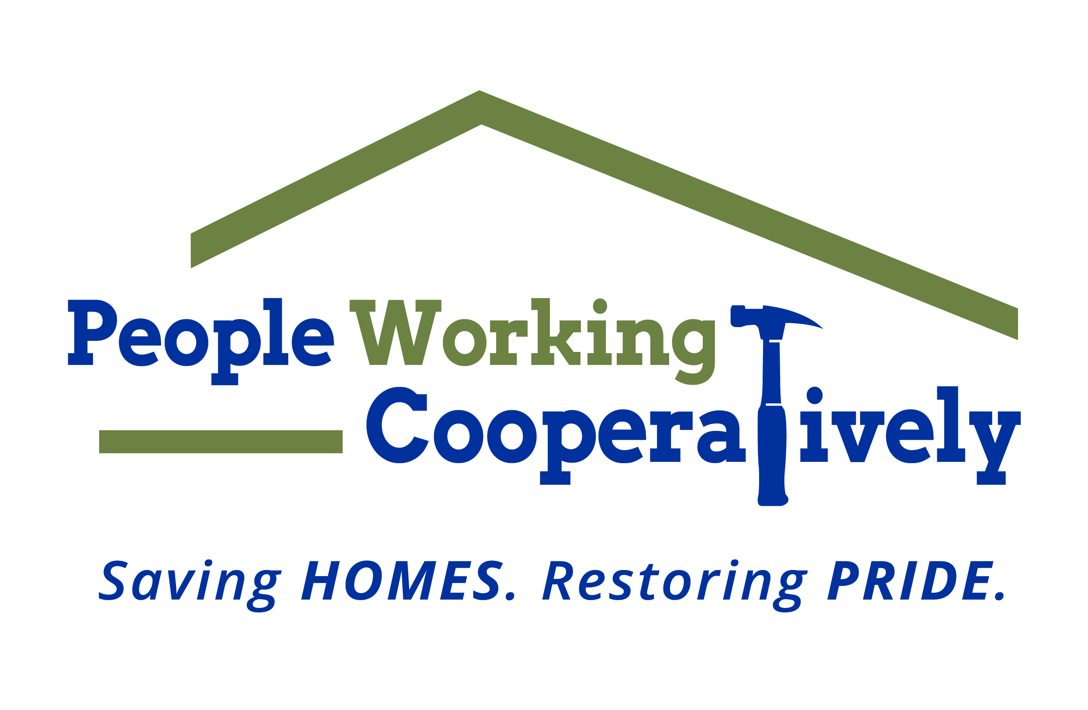
Media Contact: Jamie Glavic, Scooter Media
(859) 409-9943 | jamie@scootermediaco.com

FOR IMMEDIATE RELEASE

People Working Cooperatively Raises $230,000 at Virtual Fourth Annual Toolbelt Ball
Online Gala Supports Modifications for Mobility Program

Cincinnati, OH (July 9, 2020) – People Working Cooperatively (PWC) hosted its fourth annual ToolBelt Ball, virtually, on Saturday, June 27. The online program, emceed by Craig McKee of WCPO, included a virtual happy hour, auction, raffles, bourbon and wine pull, and paddle raiser. Net proceeds from the virtual gala are expected to be more than $230,000. Funds raised will be used to support the nonprofit’s Modifications for Mobility program, which assists low-income, elderly homeowners and people with disabilities who have mobility limitations in the Tri-State area.

“When we first postponed ToolBelt Ball in March, we were challenged with how we were going to continue to meet the growing need for modifications without our annual gala in light of the pandemic,” said Jock Pitts, PWC President and CEO. “Our pivot to a virtual fundraiser, and the support of our donors, partners and sponsors, allows us to continue to serve those who need our help the most. With more than 300 homeowners on our waiting list, every dollar counts.”

PWC will be able to complete modification services for several of those families using proceeds from this year’s ToolBelt Ball. These services could include the construction of handicapped-accessible ramps, the installation of chair/stair lifts, and bathroom modifications that improved daily mobility and independence for clients across the region.

“Planning a virtual fundraiser was a learning experience for the planning committee,” said Mike and Gail Viox, ToolBelt Ball co-chairs. “While we would have never imagined these circumstances, we’re honored to be a part of a team that rose to the challenge so that we are able to continue serving clients who rely on PWC to stay safe and healthy in their homes.”

To learn more about People Working Cooperatively, visit pwchomerepairs.org.

###

About People Working Cooperatively
Incorporated in 1975, People Working Cooperatively (PWC) is a non-profit organization
serving low-income, elderly, and disabled homeowners in 18 counties of Greater
Cincinnati, Dayton, Northern Kentucky and Indiana. PWC strengthens communities by
providing professional, critical home repair, weatherization, and modification services to
help residents stay safely in their homes. In the last 45 years, PWC’s staff of licensed,
trained employees and dedicated corps of 3,000 volunteers have assisted more than
320,000 individuals. For more information, visit pwchomerepairs.org or call (513) 351-
7921.

