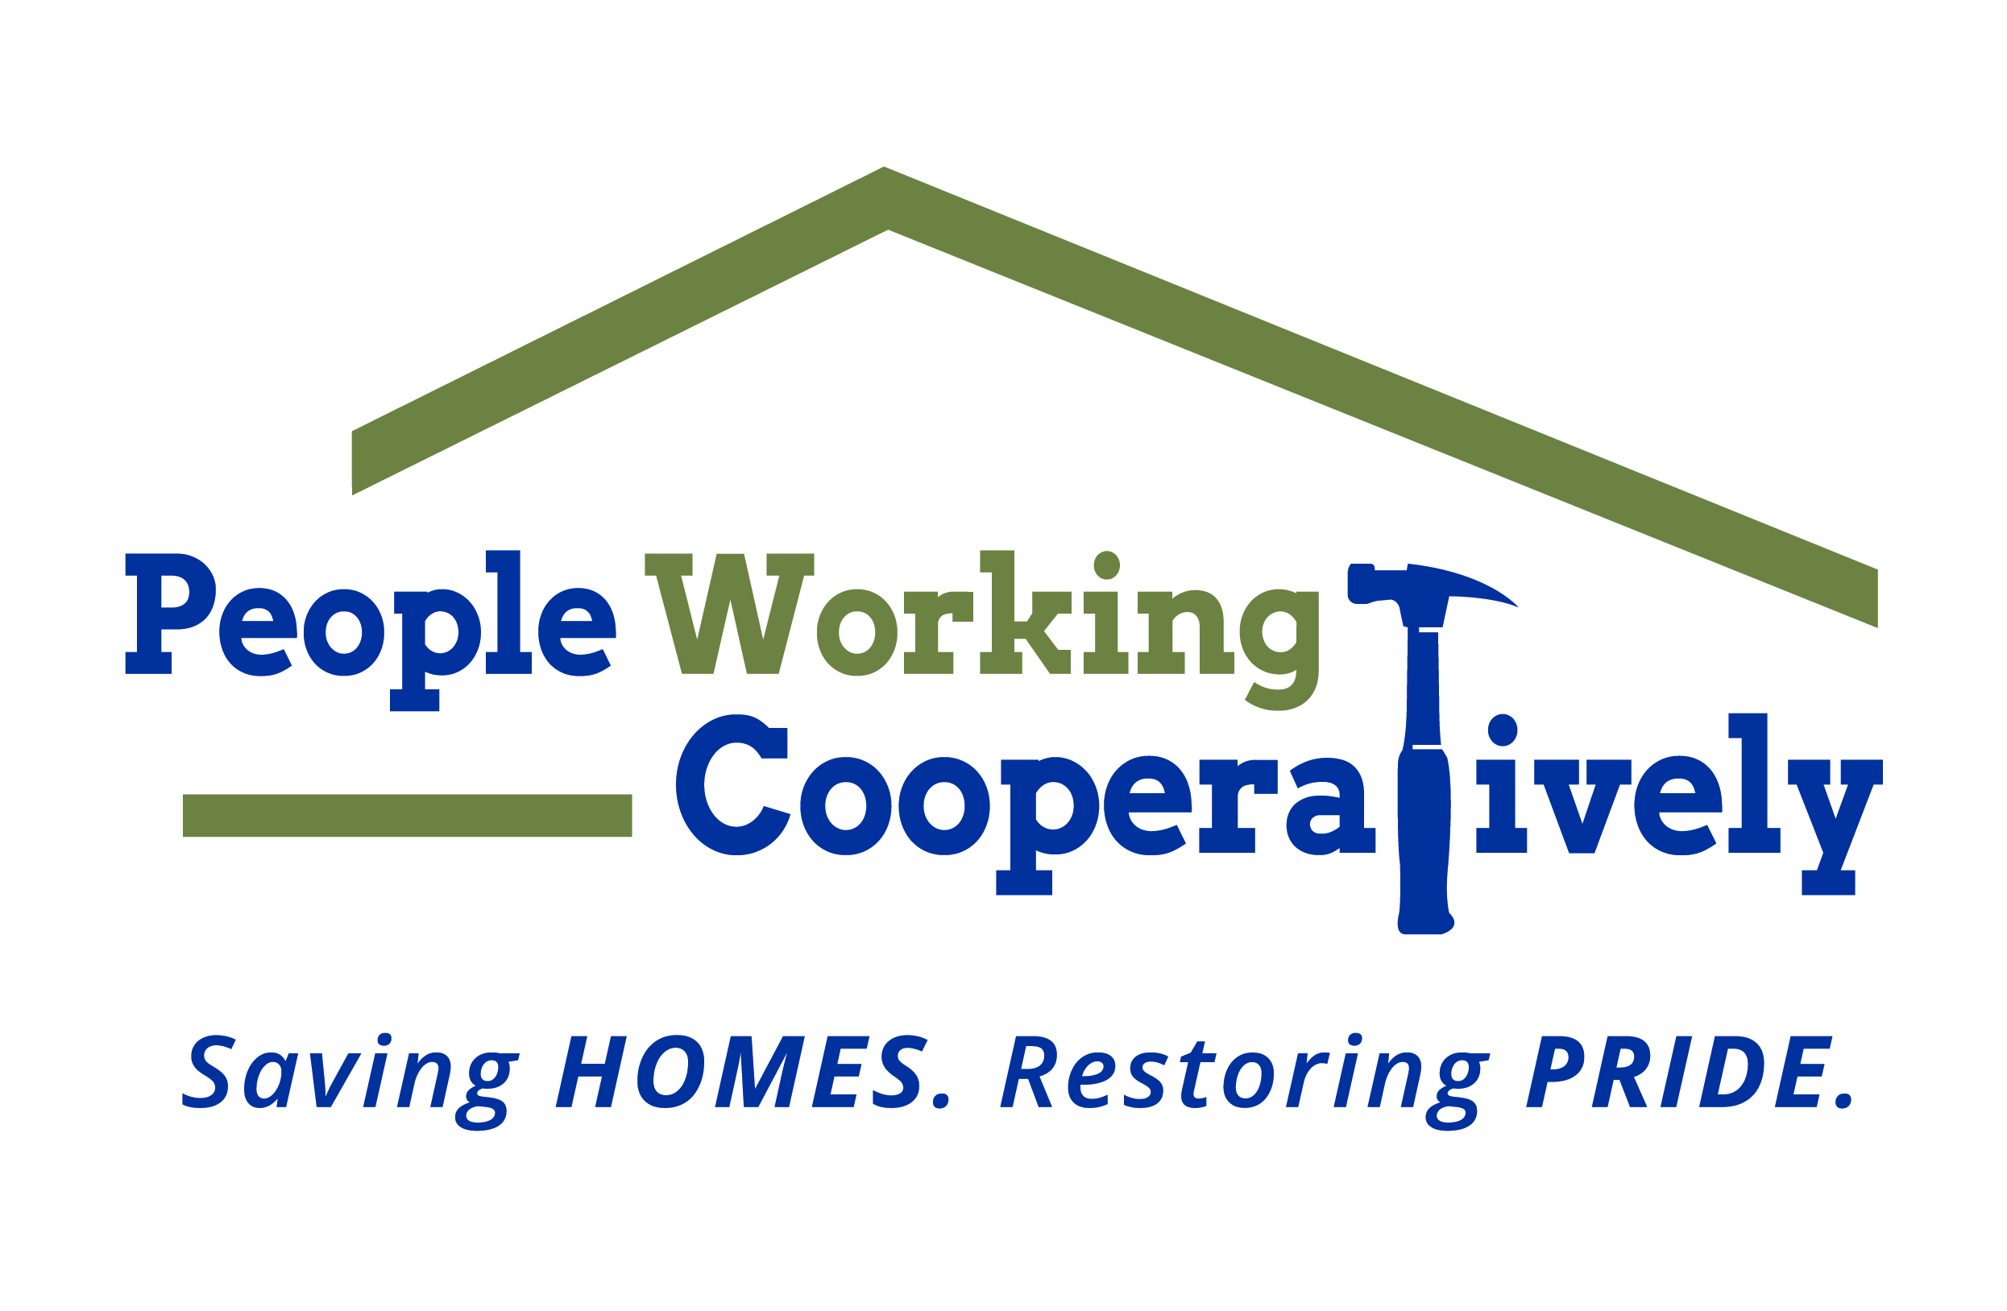
Media Contact: Jamie Glavic, Scooter Media
(859) 409-9943 | jamie@scootermediaco.com

FOR IMMEDIATE RELEASE

Winter Weather Reminders: People Working Cooperatively
Provides Home Weatherization Tips as Temperatures Drop

CINCINNATI – As the temperatures drop and snow accumulates, People Working Cooperatively (PWC) is providing weatherization services for low-income, elderly, disabled and veteran communities throughout Greater Cincinnati to help keep them safe and healthy at home.

“Health and safety in the home are incredibly intertwined. Our weatherization programs not only help our clients lower their energy bills, these programs also improve the health and safety of homes across the region,” says Staci O’Leary, People Working Cooperatively Director of Utilities & Special Programs. “In addition to insulation and air-sealing, our team addresses combustion appliances, ensuring they are drafting safely, indoor air quality issues, and more – creating safe, secure environments – improving our clients’ health and wellbeing.”

A few tips from PWC’s weatherization experts include:

- Change your furnace filters monthly to ensure your furnace is working properly.
- Be proactive and insulate vulnerable pipes in your home to avoid damage when temps drop below freezing. Take extra care to insulate pipes in areas where you have plumbing on exterior walls.
- Before you crank up the heat, make sure that all of the heat vents are open and uncovered. Sometimes rugs or furniture shift during mild months, covering the vents and the air can’t circulate properly.
- Install a programmable thermostat to adjust the temperature in your home. It
can recognize when you’re home and away and automatically adjusts to
save you money.
- If you have an older house, check your level of insulation in the attic. Often,
it’s been there for years and is no longer effective. Adding insulation can
save your furnace from working constantly to replace lost heat. Plus, it keeps
the rest of your home warmer.

To learn more about weatherizing your home, People Working Cooperatively, or to find out if you qualify for services, visit pwchomerepairs.org or call (513) 351-7921.

###

About People Working Cooperatively
Incorporated in 1975, People Working Cooperatively (PWC) is a non-profit organization serving low-income, elderly, and disabled homeowners in 19 counties of Greater Cincinnati, Dayton, Northern Kentucky and Indiana. PWC strengthens communities by providing professional, critical home repair, weatherization, and modification services to help residents stay safely in their homes. In the last 46 years, PWC’s staff of licensed, trained employees and dedicated corps of 3,000 volunteers have assisted more than 320,000 individuals. For more information, visit pwchomerepairs.org or call (513) 351-7921.

