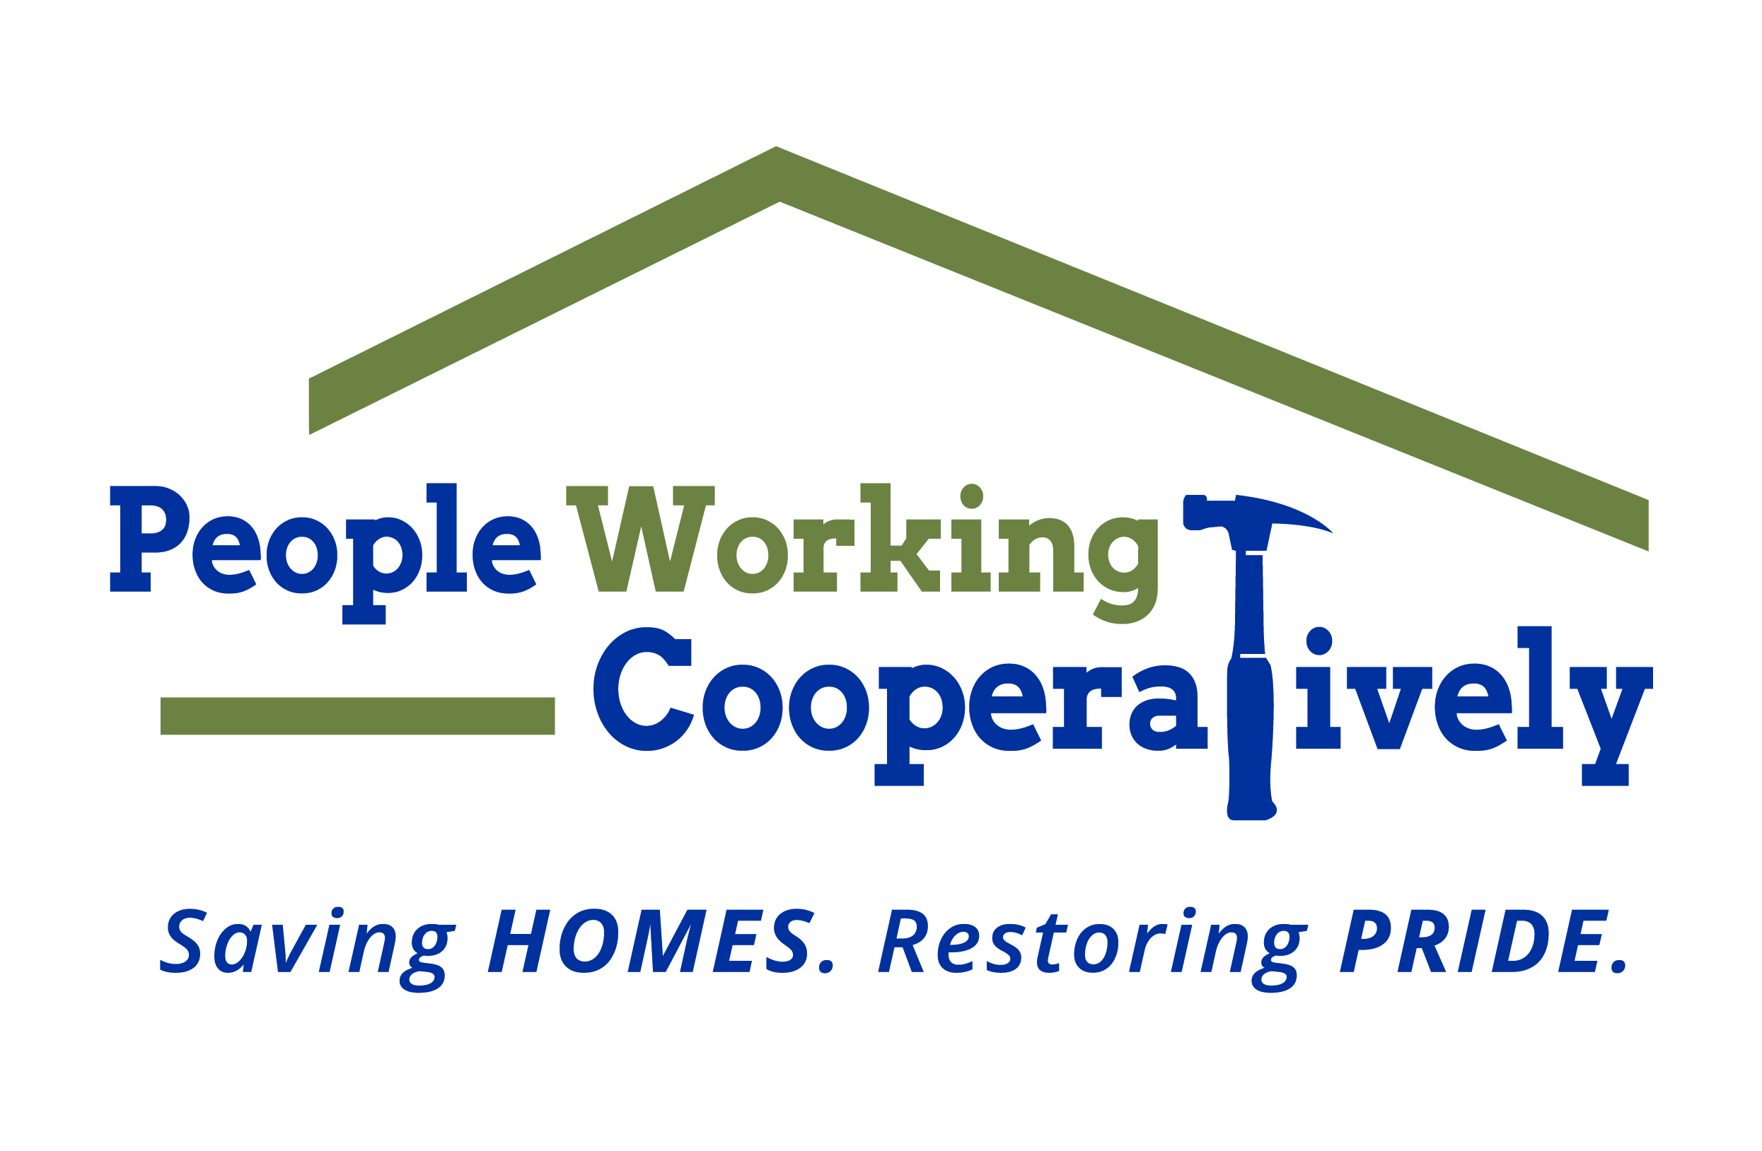

MEDIA ALERT

FOR IMMEDIATE RELEASE Contact: Drew Boehmker, Scooter Media
drew@scootermediaco.com | (859) 512-5218

Randi Kamp, People Working Cooperatively
kampr@pwchomerepairs.org| (859) 466-8714

People Working Cooperatively (PWC) and Colerain Community Team Up for 4th Annual Colerain Township “Give Back Day”

What: People Working Cooperatively will provide home repairs for 8 to 12 families during the 4th Annual Colerain Township “Give Back Day” on Saturday, October 10. This event is an innovative way for community members and local organizations to help out low-income, elderly homeowners and those living with mobility limitations or disabilities in the community.

Projects will include building accessible ramps, painting, yard work, and more. Participants will be asked to bring their own mask and practice safe social distancing.

This event is part of PWC’s socially distant community volunteer initiative, “45 Days of Service.” From October 1 to November 14, volunteers throughout the Greater Cincinnati area can give back and make a difference while helping the nonprofit celebrate its 45th anniversary of coming together to assist neighbors in need. Community members can learn more and register to volunteer at pwchomerepairs.org.

When: Saturday, October 10 from 7:30 a.m. to 12:30 p.m.

Where: The Give Back Day will begin at Colerain Park (4725 Springdale Road), where pre-registered volunteers will be dispersed to homes throughout the community to assist with various projects.

[Randi — do we have any potential media sites/addresses that we can include?]

Who: People Working Cooperatively staff and volunteers; representatives and volunteers from Colerain Township Fire & EMS, Colerain Police, Colerain Public Services, Colerain Administration, Northwest Local Schools, the Colerain Chamber of Commerce, and other community organizations.

Why: Opportunity to take photos and video of a local nonprofit and a community coming together to serve neighbors in need of critical home repairs.

About People Working Cooperatively
Incorporated in 1975, People Working Cooperatively (PWC) is a nonprofit organization serving low-income, elderly, and disabled homeowners in 20 counties of Greater Cincinnati, Dayton, Northern Kentucky and Indiana. PWC strengthens communities by providing professional, critical home repair, weatherization, and modification services to help residents stay safely in their homes. In the last 44 years, PWC’s staff of licensed, trained employees and dedicated corps of 3,000 volunteers have assisted more than 310,000 individuals. For more information, visit www.pwchomerepairs.org or call (513) 351-7921.

# # #

