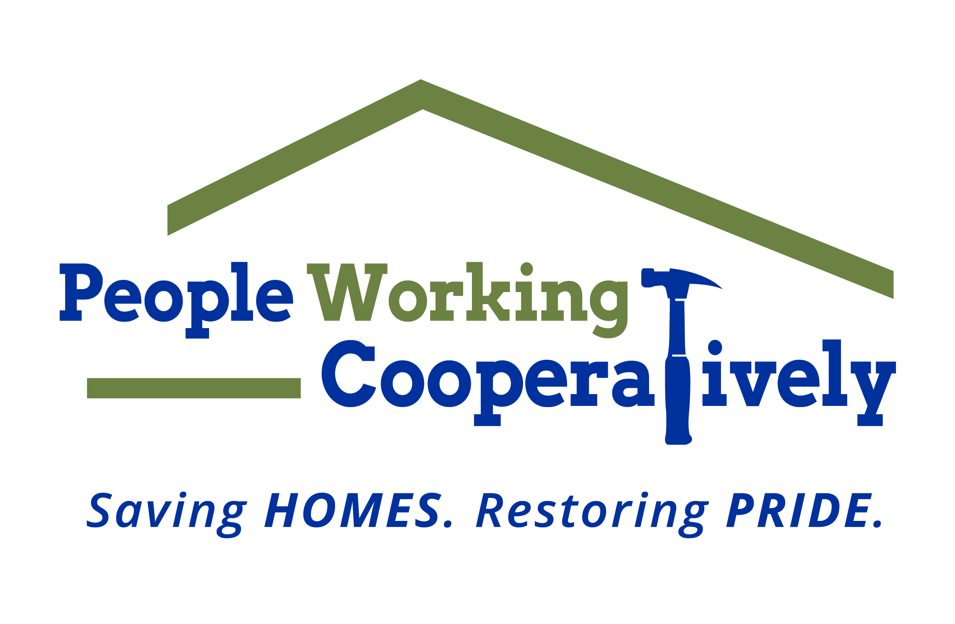

**Media Contact:** Jamie Glavic, Scooter Media

(859) 409-9943 | [jamie@scootermediaco.com](mailto:jamie@scootermediaco.com)

FOR IMMEDIATE RELEASE

**PEOPLE WORKING COOPERATIVELY’S 4TH ANNUAL TOOLBELT BALL**

**GOES VIRTUAL**

**Cincinnati, OH** (May 22, 2020) – People Working Cooperatively (PWC) has a new date and a fresh look for its 4th Annual ToolBelt Ball, which will be held online on Saturday, June 27. While the format of the gala may be different, the goal remains the same: bringing together some of Cincinnati’s best to support PWC’s “Modifications for Mobility” program, which assists low-income, elderly homeowners and those living with mobility limitations or disabilities.

“Like many organizations, we’ve had to pivot to continue serving our clients during this challenging time,” said Jock Pitts, President & CEO of PWC. “The funds we raise at this event every year support critical projects across the region, allowing those in need remain safe and healthy at home. Our team’s creativity and dedication to our mission have made this virtual event possible.”

In the week leading up to the gala, PWC will kick off the virtual ToolBelt Ball celebration on the ToolBelt Ball website (toolbeltball.provirtualevent.com) and on social media with the theme of #HomeSafeHome. Beginning Sunday, June 21, PWC will premiere videos featuring local families whose lives have been positively impacted by PWC, highlight auction items and Golden Ticket prizes, host raffle drawings, recognize sponsors and ToolBelt Ball committee members, and more.

“Organizing this year’s ToolBelt Ball has been a learning experience,” said Mike and Gail Viox, ToolBelt Ball co-chairs. “We’re passionate about PWC’s mission and are thrilled to bring the gala to life in a new way. While we would have never imagined these circumstances, we’re honored to be a part of a team that rose to the challenge so that we are able to continue serving clients who rely on PWC to stay safe and healthy in their homes.”

In 2019, PWC completed life-changing modification services for 63 families using proceeds of over $220,000 from last year’s ToolBelt Ball. These services included the construction of accessible ramps, the installation of chair/stair lifts, and bathroom modifications that improved daily mobility and independence for our clients.

To learn more visit toolbeltball.provirtualevent.com.

###

**About People Working Cooperatively**

Incorporated in 1975, People Working Cooperatively (PWC) is a non-profit organization serving low-income, elderly, and disabled homeowners in 18 counties of Greater Cincinnati, Dayton, Northern Kentucky and Indiana. PWC strengthens communities by providing professional, critical home repair, weatherization, and modification services to help residents stay safely in their homes. In the last 45 years, PWC’s staff of licensed, trained employees and dedicated corps of 3,000 volunteers have assisted more than 320,000 individuals. For more information, visit [pwchomerepairs.org](http://www.pwchomerepairs.org/) or call (513) 351-7921.