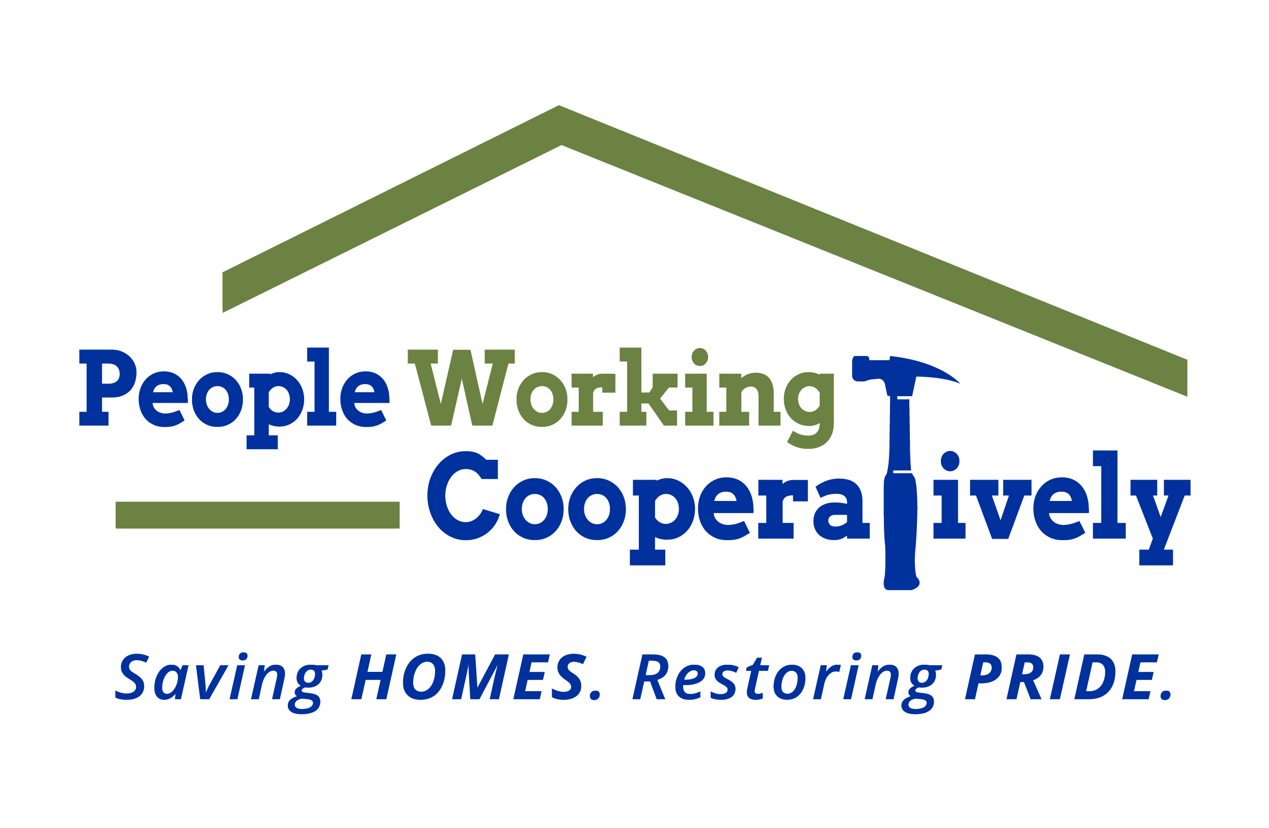
Media Contact: Jamie Glavic, Scooter Media
(859) 409-9943 | jamie@scootermediaco.com

FOR IMMEDIATE RELEASE

Middletown Community Foundation Awarded $19,000 to People Working Cooperatively

Cincinnati (September 14, 2020) – People Working Cooperatively (PWC) received $19,000 in grant funding from the Middletown Community Foundation to provide home repairs and modifications in the local community.

PWC technicians provided critical home repairs for 19 Middletown residents, ages 43 to 88, including electrical, HVAC, plumbing and exterior work.

“The grant support we receive helps us fulfill our mission of assisting neighbors in need stay safe and healthy in their own home,” said Chris Owens, Vice President of Development for People Working Cooperatively. “Thanks to the generosity of the Middletown Community Foundation, PWC was able to improve the quality of life for 19 residents in 16 households in Middletown.”

To learn more about People Working Cooperatively or to find out if you are eligible for services, visit pwchomerepairs.org or call (513) 351-7921.

###

About People Working Cooperatively
Incorporated in 1975, People Working Cooperatively (PWC) is a non-profit organization serving low-income, elderly, and disabled homeowners in 20 counties of Greater Cincinnati, Dayton, Northern Kentucky and Indiana. PWC strengthens communities by providing professional, critical home repair, weatherization, and modification services to help residents stay safely in their homes. In the last 45 years, PWC’s staff of licensed, trained employees and dedicated corps of 3,000 volunteers have assisted more than 320,000 individuals. For more information, visit pwchomerepairs.org or call (513) 351-7921.

